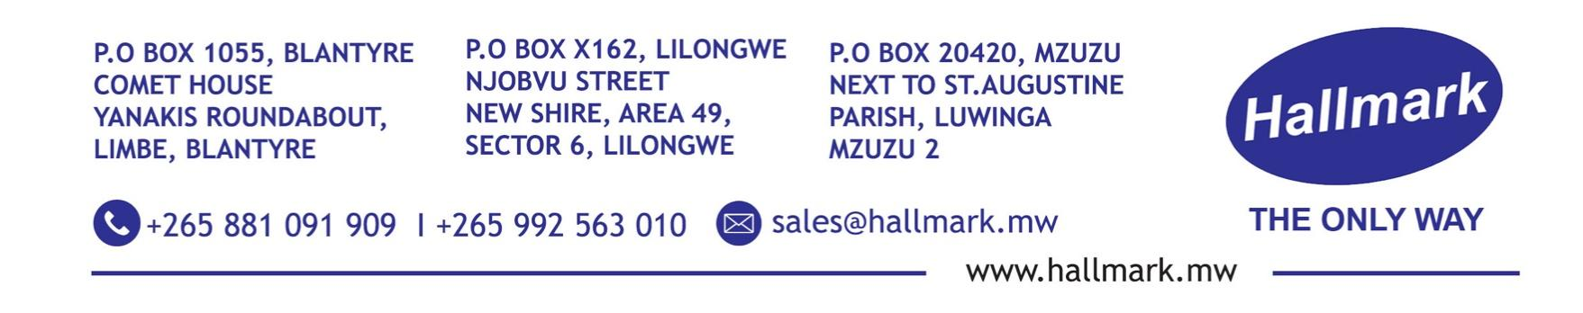

Hallmark Limited – Healthcare Business Unit

Business Profile | 2026 Edition

Overview

Hallmark Limited’s Healthcare Business Unit supplies, installs, and supports medical equipment, laboratory solutions, and healthcare facility systems that enable hospitals, clinics, and laboratories to deliver safe, effective, and compliant care.

We partner with public and private health providers, NGOs, UN agencies, and donor-funded programs across Sub-Saharan Africa. Our focus is reliability: every device, consumable, and system is sourced from globally certified manufacturers, verified for quality, and backed by local biomedical engineering support and training.

We understand that in healthcare, downtime is not an option. Our model combines international standards with on-the-ground execution to maximize equipment uptime, ensure regulatory compliance, and improve patient outcomes.

Our Vision

To be Africa’s most dependable partner for healthcare technology and supplies that strengthen health systems and save lives.

Our Mission

To deliver quality-assured medical equipment, diagnostics, and facility solutions through certified sourcing, responsive service, and measurable impact on clinical delivery.

Core Solutions

- Medical Equipment & Critical Care

Diagnostic, monitoring, and life-support systems for hospitals, clinics, and field hospitals.

- Patient monitors, ECG, defibrillators, and anesthesia machines

- Ultrasound, digital X-ray, and portable imaging systems

- Ventilators, infusion pumps, and critical care devices

- Sterilization units, autoclaves, and instrument washers

- Theatre tables, examination couches, and hospital furniture

- All equipment is supplied with installation, commissioning, user training, warranty, and after-sales support.

- Laboratory Diagnostics & Supplies

End-to-end solutions for clinical and research laboratories.

- Diagnostic test kits and reagents for chemistry, hematology, microbiology, and molecular diagnostics

- Microscopes, centrifuges, analyzers, and analytical instruments

- Laboratory glassware, plastics, consumables, and biosafety equipment

- Cold chain storage, sample transport, and lab informatics solutions

- Water Treatment & Laboratory Chemicals

Chemicals and systems that maintain water quality and lab standards to ISO 17025 and WHO guidelines.

- Water purification systems, RO units, and deionization systems

- Scale and corrosion inhibitors, disinfectants, and lab-grade reagents with Certificates of Analysis

- Chemical handling, storage, and spill management solutions compliant with OSHA and GHS standards

- Personal Protective Equipment & Infection Control

Certified PPE and consumables for clinical environments.

- Surgical gowns, gloves, masks, face shields, and protective eyewear

- Isolation gowns, disposable coveralls, and biohazard containment kits

- Hand hygiene systems, disinfectants, and infection prevention products meeting WHO and CDC standards

- Facility & Emergency Systems

Infrastructure solutions that ensure safety and continuity of care.

- Backup power: UPS, diesel generators, and solar-hybrid systems

- Fire suppression, detection, and evacuation systems

- Emergency communication and nurse call systems

- Environmental monitoring for temperature, humidity, and air quality in labs, pharmacies, and operating theatres

Our Delivery Process

- Needs Assessment & Clinical Alignment

We work with your medical, technical, and procurement teams to define requirements based on patient volume, service level, power/water infrastructure, and budget.

- Certified Sourcing & Verification

Equipment and consumables are sourced from ISO 13485, CE-marked, FDA-approved, or WHO-prequalified manufacturers. Full traceability and documentation provided.

- Logistics, Installation & Commissioning

We manage importation, customs clearance, delivery, installation, calibration, and performance testing to ensure equipment meets specification.

- Training & Knowledge Transfer

Clinical and biomedical staff receive hands-on training, SOPs, and competency assessments for safe operation and basic maintenance.

- Lifecycle Support

Preventive maintenance contracts, spare parts supply, calibration services, and 24/7 technical support minimize downtime and extend asset life.

Quality, Regulatory & Compliance

- Sourcing from ISO 13485 and ISO 9001 certified manufacturers

- Products supplied with CE, FDA, WHO PQ, and Certificates of Conformity

- Local biomedical engineering team for preventive maintenance, calibration, and rapid repairs

- Full documentation for donor audits, regulatory inspections, and accreditation processes

- Compliance with Ministry of Health guidelines and WHO Medical Device Regulations

What Sets Us Apart

- Local Biomedical Engineering Capacity

Our certified biomedical engineers are based in Malawi and Zambia, enabling 24-72 hour response times and reducing dependency on overseas service teams.

- End-to-End Lifecycle Management

Single accountability from procurement through installation, training, maintenance, and decommissioning. No vendor fragmentation.

- Context-Appropriate Sourcing

We specify equipment suited to local power stability, water quality, and technical capacity. No over-engineering, no hidden costs.

- Donor & NGO Compliance Expertise

Experienced in fulfilling procurement, reporting, and QA requirements for USAID, Global Fund, UNICEF, and World Bank-funded projects.

- Responsive Supply Chain

Direct partnerships with manufacturers in Europe, Asia, and South Africa enable competitive pricing, authentic spare parts, and 4-8 week lead times for most equipment.

Markets We Serve

Public and private hospitals and referral centers

- Primary health clinics and rural health centers

- Diagnostic and research laboratories

- UN agencies, NGOs, and donor-funded health programs

- Occupational health, corporate clinics, and mining health facilities

- Veterinary and agricultural laboratories

Client Outcomes

Healthcare providers working with us achieve:

- Higher equipment uptime through local maintenance and rapid spare parts supply

- Reduced procurement lead times and fewer stockouts of critical consumables

- Improved compliance with infection prevention, biosafety, and equipment standards

- Lower total cost of ownership through right-sized equipment and efficient servicing

- Audit-ready documentation for donor and regulatory reporting

Quality Assurance & Documentation

Every delivery includes full traceability: commercial invoices, packing lists, Certificates of Analysis, warranties, user manuals, and service logs. Preventive maintenance schedules and digital service reports support accreditation and donor reporting requirements.

Contact

Hallmark Limited – Healthcare Business Unit
Email: healthcare@hallmark.mw
Website: www.hallmark.mw
Phone: +265 881 091 909 | +265 992 563 010
WhatsApp: +265 881 091 909

Head Office – Malawi
Area 47, Sector 1, Nzinziri Street,
- O. Box 162, Lilongwe, Malawi

Zambia Office
Plot 160, Silverest, Lusaka, Zambia

Regional Office – Blantyre
Comet House, Yanakis Roundabout, Limbe, Blantyre, Malawi

THE ONLY WAY

